**Filtro BS Chebyshev I**

|  |  |
| --- | --- |
| **Quantizado 31 bits Forma direta II Second-Order Sections** | |
| --------------------------  Section #1  --------------------------  Quantized Numerator:  1  -0.46916635334491729736328125  1.089938461780548095703125  Quantized Denominator:  1  -0.2964711226522922515869140625  0.41814742051064968109130859375  Quantized Gain:  0.52686798572540283203125  --------------------------  Section #2  --------------------------  Quantized Numerator:  1  -0.3780455850064754486083984375  1.0826715417206287384033203125  Quantized Denominator:  1  -0.0416371636092662811279296875  0.82487000338733196258544921875  Quantized Gain:  1  --------------------------  Section #3  --------------------------  Quantized Numerator:  1  -0.43045214377343654632568359375  0.91748299263417720794677734375  Quantized Denominator:  1  -0.70038955472409725189208984375  0.83701942861080169677734375  Quantized Gain:  1  --------------------------  Section #4  --------------------------  Quantized Numerator:  1  -0.3491784594953060150146484375  0.92364116571843624114990234375  Quantized Denominator:  1  -0.16408178769052028656005859375  0.9511614143848419189453125  Quantized Gain:  1  --------------------------  Section #5  --------------------------  Quantized Numerator:  1  -0.4948164783418178558349609375  1.0235830657184123992919921875  Quantized Denominator:  1  -0.63968464545905590057373046875  0.9534332118928432464599609375  Quantized Gain:  1  --------------------------  Section #6  --------------------------  Quantized Numerator:  1  -0.32172205857932567596435546875  1.0000000037252902984619140625  Quantized Denominator:  1  -0.209914527833461761474609375  0.9881243966519832611083984375  Quantized Gain:  1  --------------------------  Section #7  --------------------------  Quantized Numerator:  1  -0.48341603390872478485107421875  0.97696027345955371856689453125  Quantized Denominator:  1  -0.612816631793975830078125  0.98874096386134624481201171875  Quantized Gain:  1  --------------------------  Quantized Output Gain:  1 | --------------------------  Section #1  --------------------------  Reference Numerator:  1  -0.469166353343302366951661497296299785376  1.089938462111465389270392734033521264791  Reference Denominator:  1  -0.296471121860306774387083805777365341783  0.418147419943034726053099348064279183745  Reference Gain:  0.52686798572540283203125  --------------------------  Section #2  --------------------------  Reference Numerator:  1  -0.378045584676843460236739247193327173591  1.082671541690784389189161629474256187677  Reference Denominator:  1  -0.041637164292504913465364779767696745694  0.824870003482086389112737379036843776703  Reference Gain:  1  --------------------------  Section #3  --------------------------  Reference Numerator:  1  -0.430452143670377374018443106251652352512  0.917482992216778869831728115968871861696  Reference Denominator:  1  -0.700389554923104618033846691105281934142  0.837019427891170231248452182626351714134  Reference Gain:  1  --------------------------  Section #4  --------------------------  Reference Numerator:  1  -0.349178459939221697005962141702184453607  0.92364116499754078670747503565507940948  Reference Denominator:  1  -0.164081787063079020949629693859606049955  0.951161413532358501754515600623562932014  Reference Gain:  1  --------------------------  Section #5  --------------------------  Reference Numerator:  1  -0.494816477800395393416010847431607544422  1.023583065735208075253126480674836784601  Reference Denominator:  1  -0.639684645176383459563851374696241691709  0.953433212065612156749239147757180035114  Reference Gain:  1  --------------------------  Section #6  --------------------------  Reference Numerator:  1  -0.321722059079580513518692441721213981509  1.000000002854211311742460566165391355753  Reference Denominator:  1  -0.209914527018254137846753337726113386452  0.988124396269516647173247747559798881412  Reference Gain:  1  --------------------------  Section #7  --------------------------  Reference Numerator:  1  -0.483416033232757058613060507923364639282  0.976960273175654259070199714187765493989  Reference Denominator:  1  -0.612816631566394542929288036248181015253  0.988740963755510349209032483486225828528  Reference Gain:  1  --------------------------  Reference Output Gain:  1 |

|  |  |
| --- | --- |
| **Comparativo** | |
| Discrete-Time IIR Filter (real)  -------------------------------  Filter Structure : Direct-Form II  Numerator Length : 15  Denominator Length : 15  Stable : Yes  Linear Phase : No  Arithmetic : fixed  Numerator : s31,24 -> [-64 64)  Denominator : s31,24 -> [-64 64)  Input : s16,15 -> [-1 1)  Output : s16,4 -> [-2048 2048)  State : s16,15 -> [-1 1)  Numerator Prod : s47,39 -> [-128 128)  Denominator Prod : s47,39 -> [-128 128)  Numerator Accum : s40,28 -> [-2048 2048)  Denominator Accum : s40,28 -> [-2048 2048)  Round Mode : convergent  Overflow Mode : wrap  Cast Before Sum : true    Implementation Cost  Number of Multipliers : 29  Number of Adders : 28  Number of States : 14  Multiplications per Input Sample : 29  Additions per Input Sample : 28 | Discrete-Time IIR Filter (real)  -------------------------------  Filter Structure : Direct-Form II, Second-Order Sections  Number of Sections : 7  Stable : Yes  Linear Phase : No  Arithmetic : fixed  Numerator : s31,29 -> [-2 2)  Denominator : s31,29 -> [-2 2)  Scale Values : s31,30 -> [-1 1)  Input : s16,15 -> [-1 1)  Section Input : s16,10 -> [-32 32)  Section Output : s16,11 -> [-16 16)  Output : s16,11 -> [-16 16)  State : s16,15 -> [-1 1)  Numerator Prod : s47,44 -> [-4 4)  Denominator Prod : s47,44 -> [-4 4)  Numerator Accum : s40,35 -> [-16 16)  Denominator Accum : s40,35 -> [-16 16)  Round Mode : convergent  Overflow Mode : wrap  Cast Before Sum : true    Implementation Cost  Number of Multipliers : 29  Number of Adders : 28  Number of States : 14  Multiplications per Input Sample : 29  Additions per Input Sample : 28 |

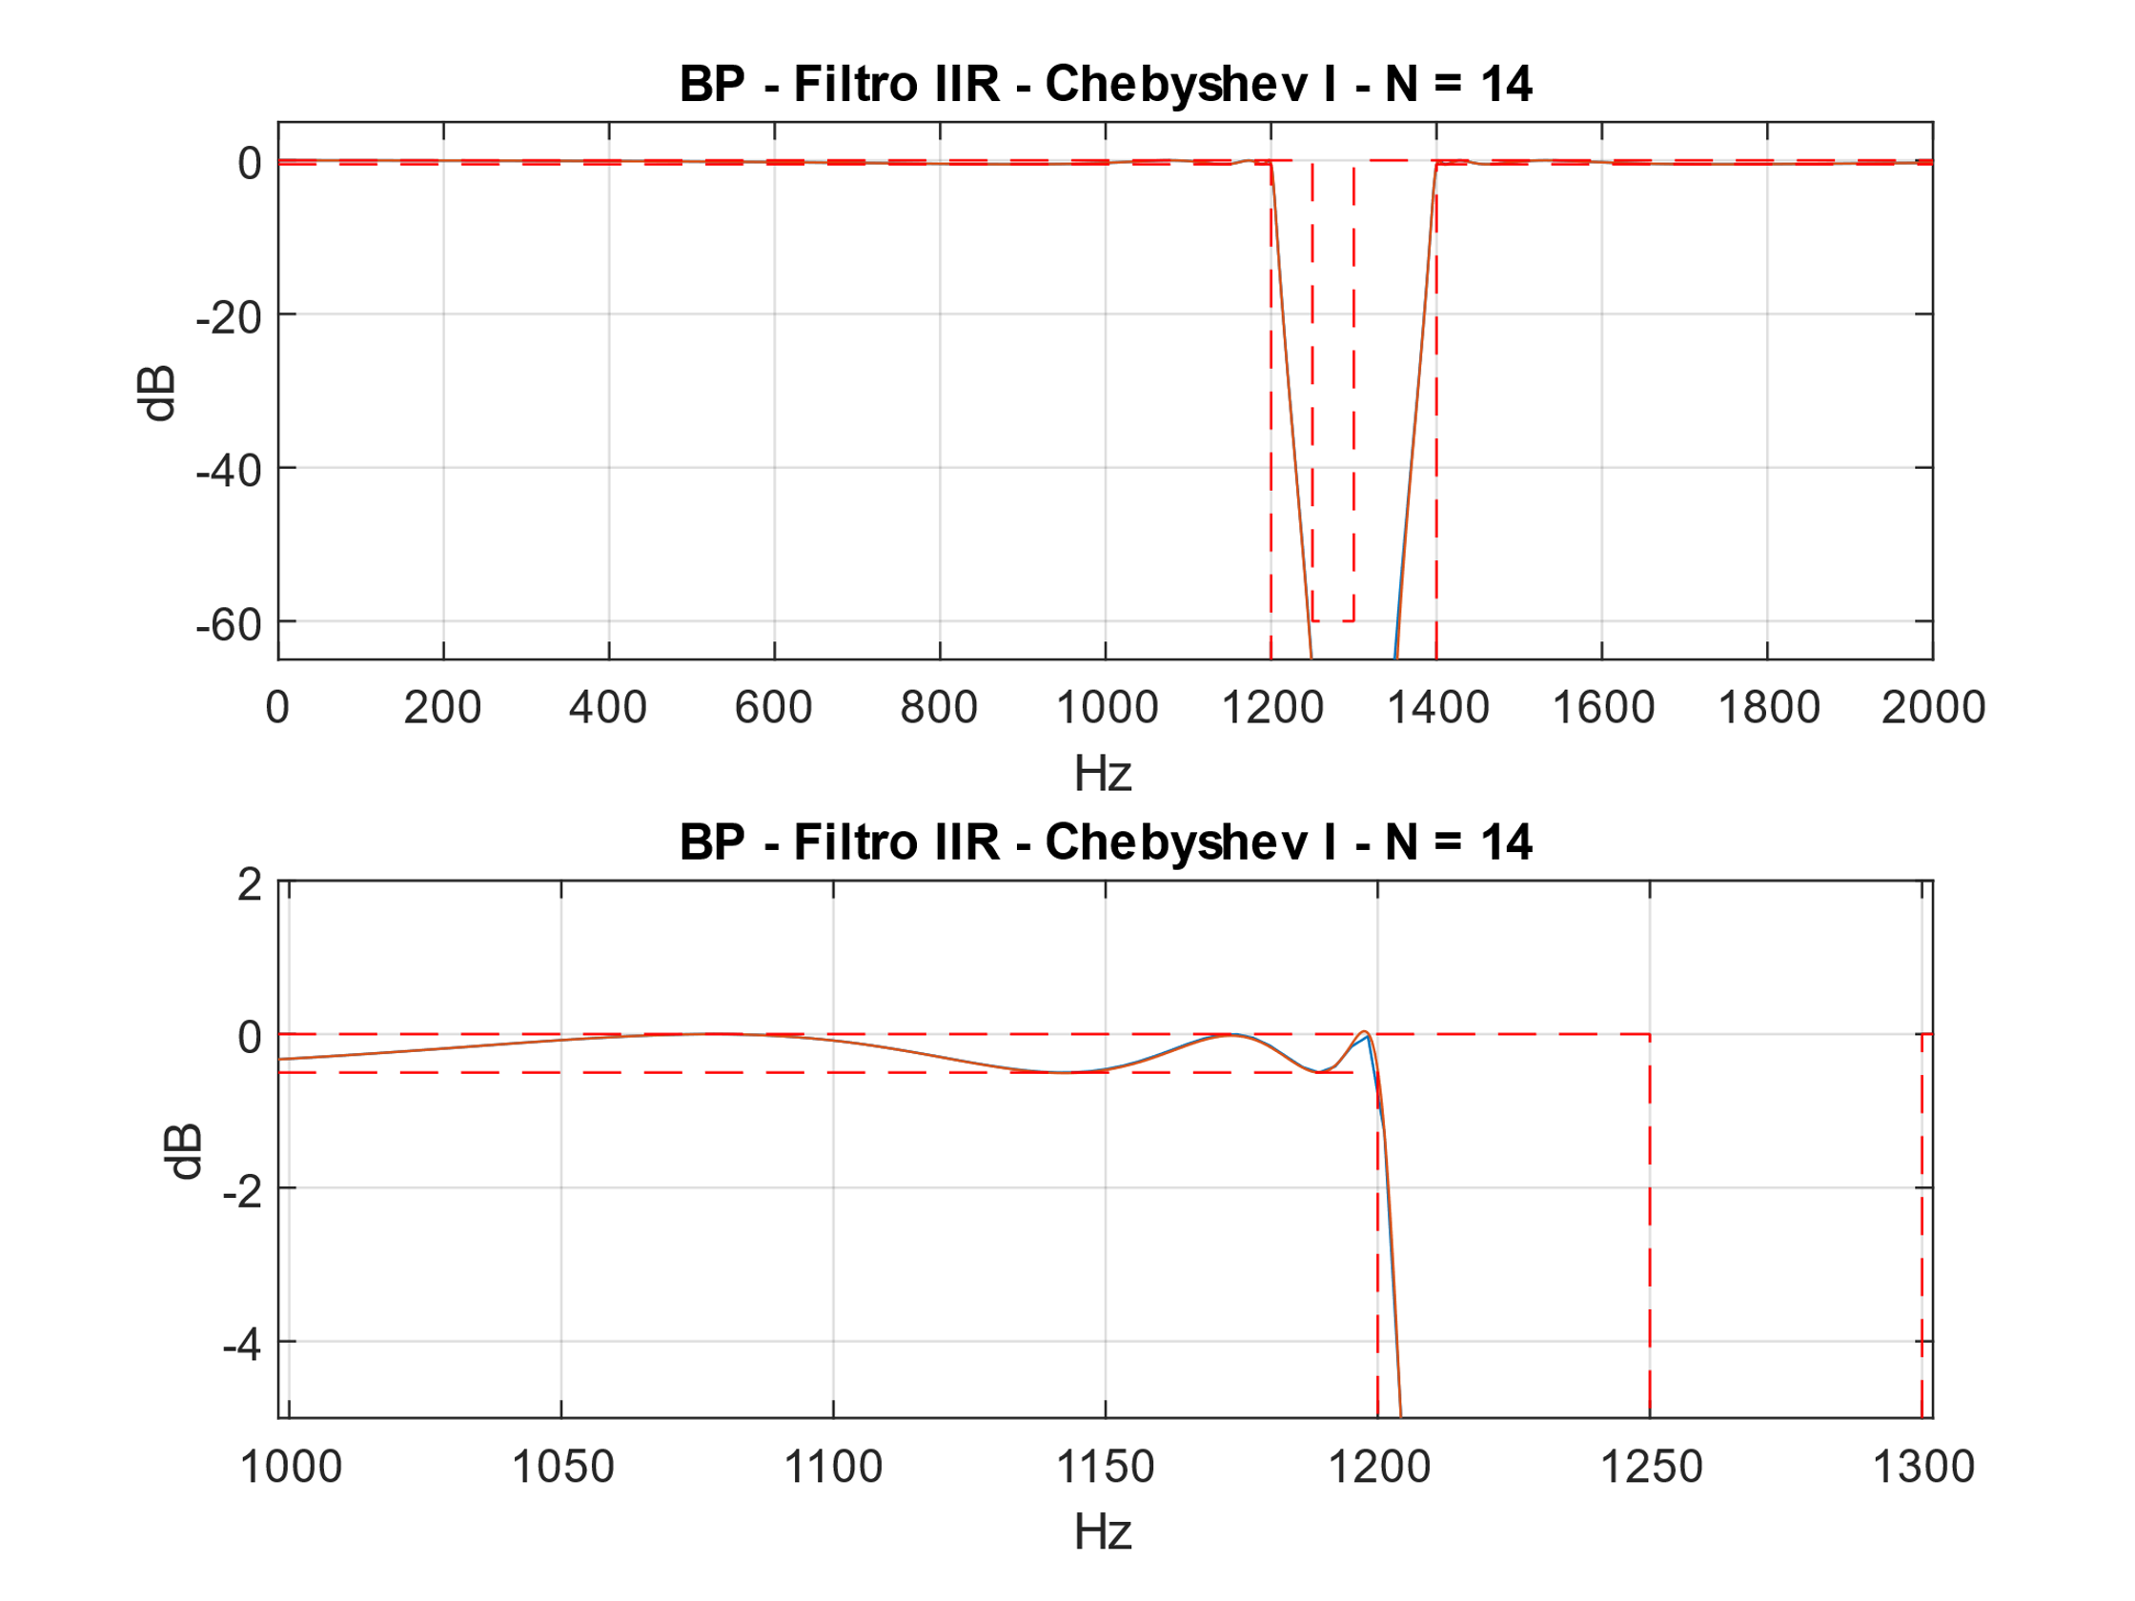

Figura 1 - Filtro DFII

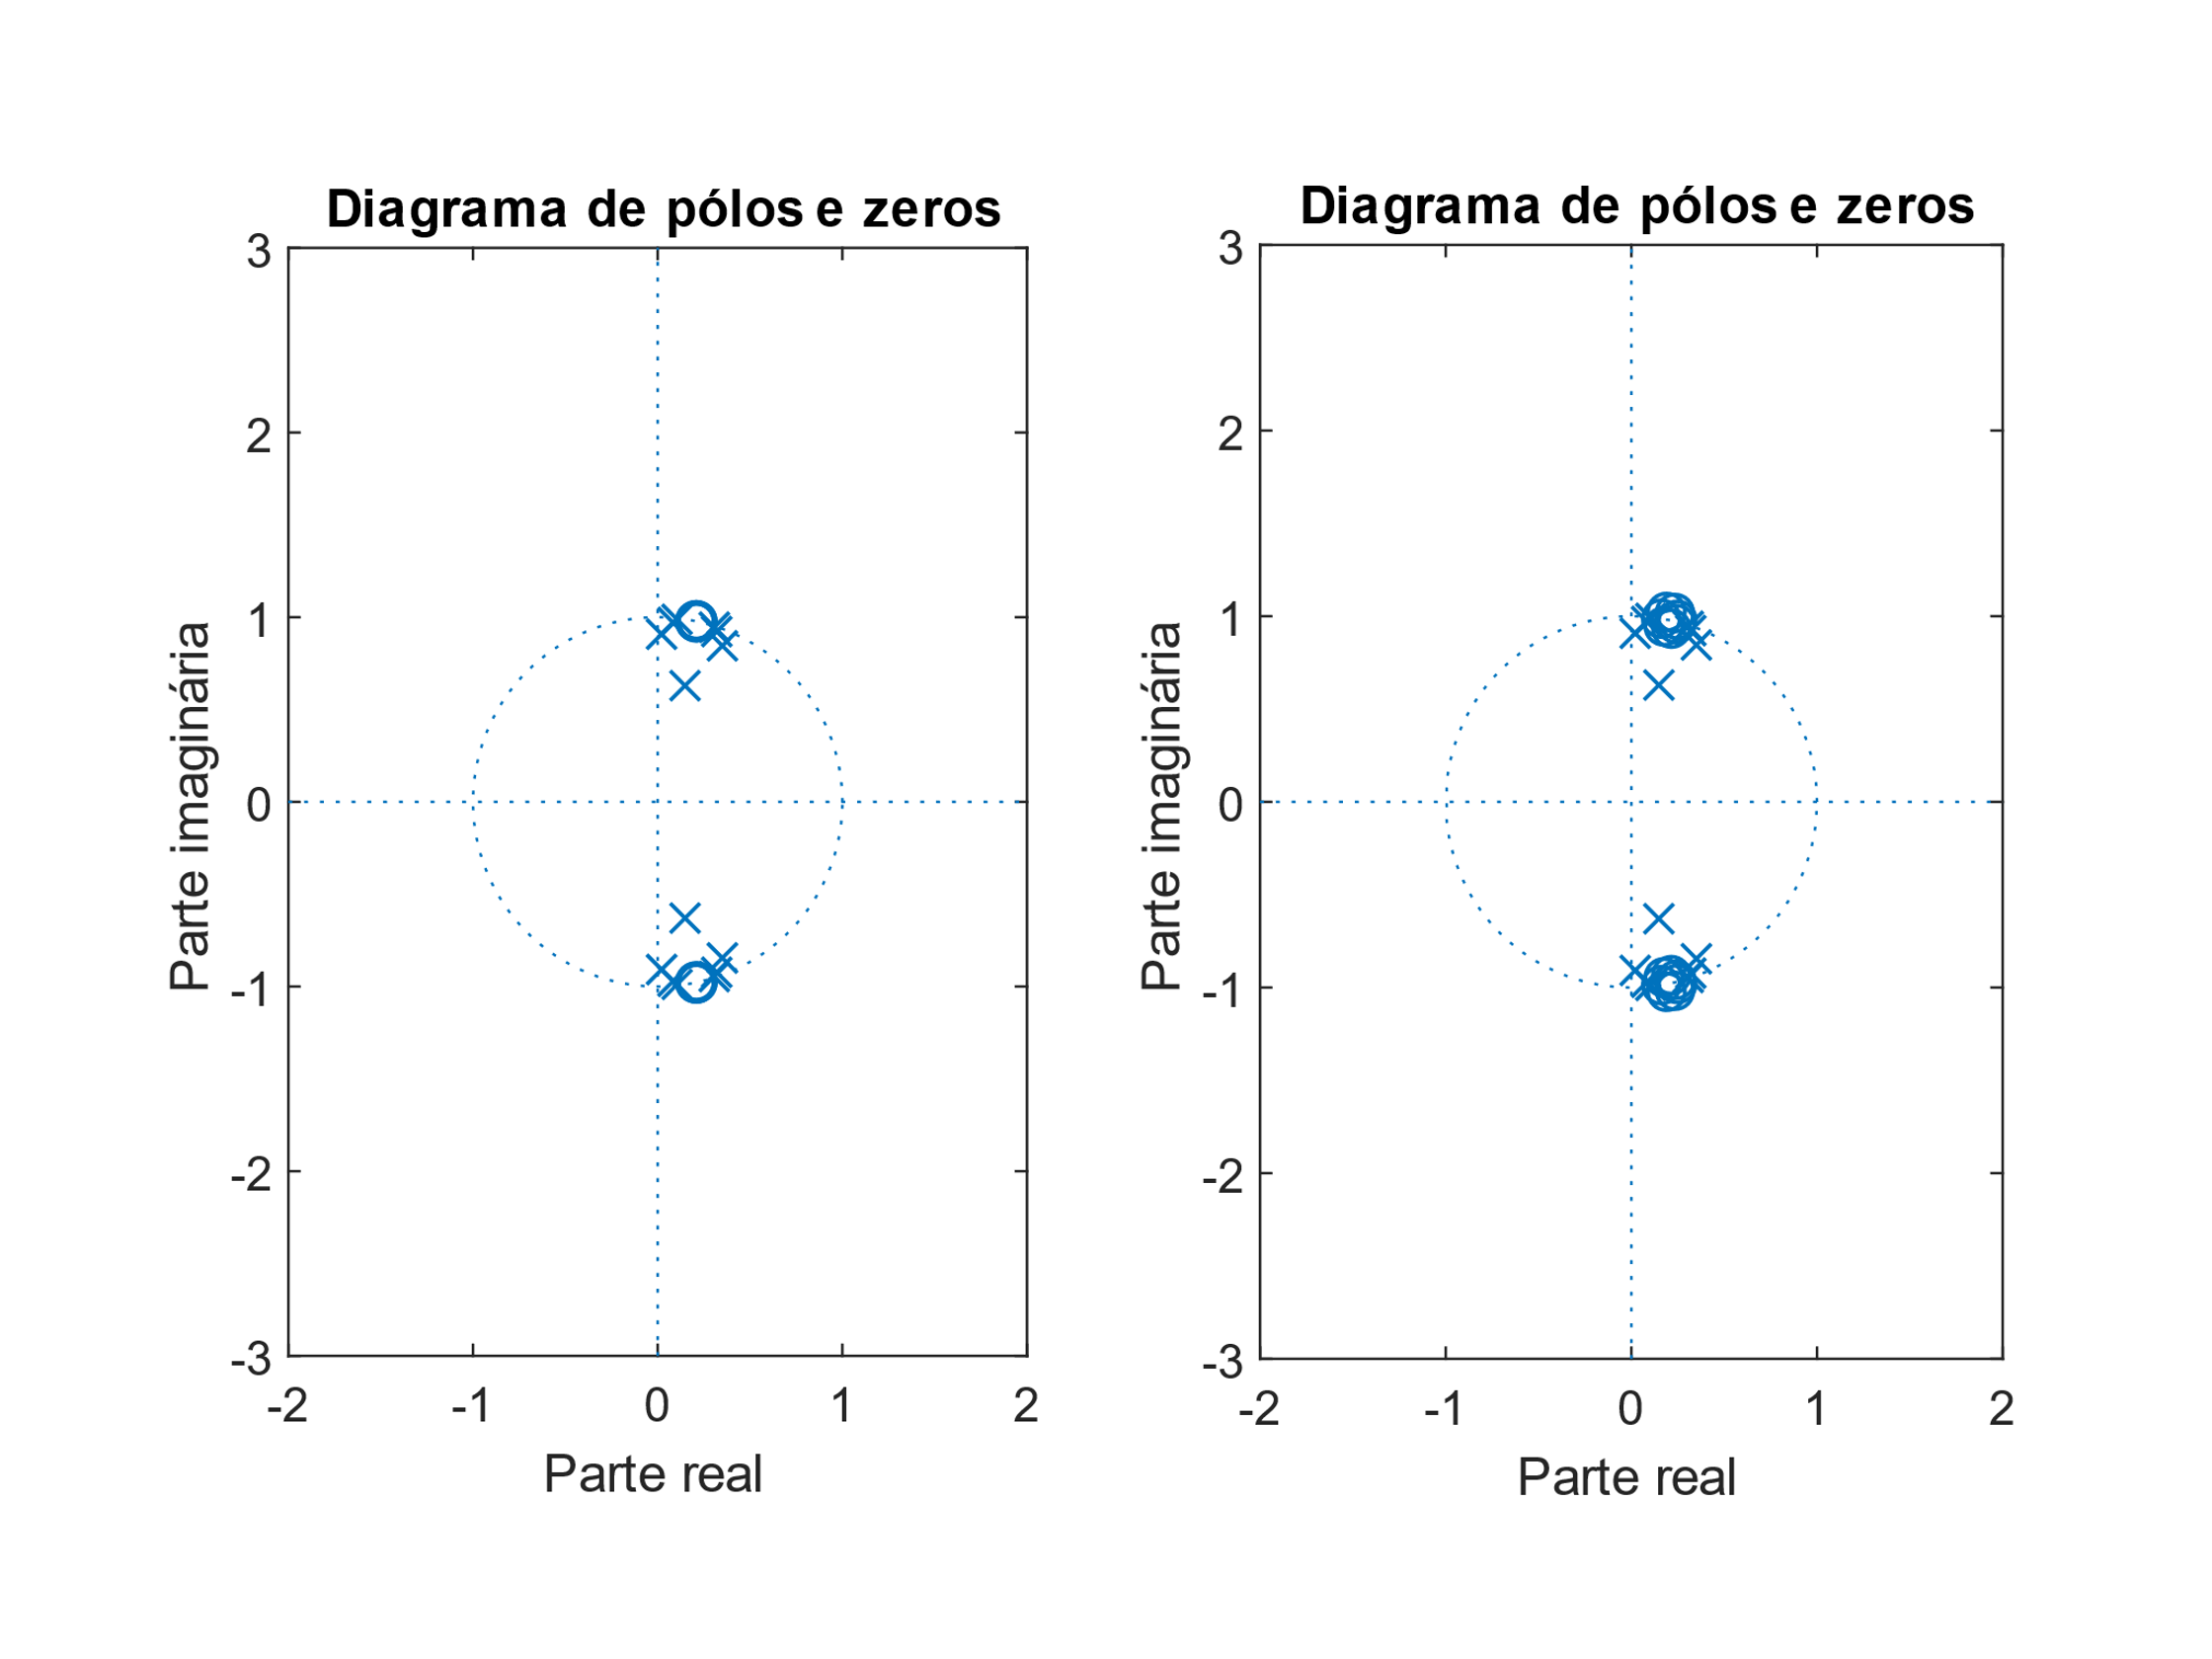

Figura 2 - Filtro DFII

ASIC:

(2M + S + D) * nº bits

(2 * 29 + 28 + 14) * 31 = 3100 elementos

FPGA:

(2M + S) * nº bits

(2 * 29 + 28) * 31 = 2666 elementos

**Filtro BS PM**

|  |  |
| --- | --- |
| **Quantized Numerator 8bits** | **Reference Numerator** |
| 0.00939178466796875  0.00168609619140625  -0.0012359619140625  0.00145721435546875  -0.001708984375  0.00103759765625  -0.00063323974609375  0.00136566162109375  -0.00128936767578125  0.00023651123046875  -0.00061798095703125  0.00144195556640625  -0.00040435791015625  -0.00009918212890625  -0.0011749267578125  0.0008544921875  0.0004730224609375  0.0005645751953125  -0.0012969970703125  -0.0004119873046875  0.00026702880859375  0.0015106201171875  -0.0001678466796875  -0.00112152099609375  -0.001129150390625  0.001251220703125  0.00146484375  -0.00012969970703125  -0.0021820068359375  -0.00060272216796875  0.0017547607421875  0.00189208984375  -0.00128936767578125  -0.0023956298828125  -0.0000457763671875  0.0027313232421875  0.00110626220703125  -0.002105712890625  -0.00225067138671875  0.00122833251953125  0.00261688232421875  0.0001220703125  -0.002532958984375  -0.0011138916015625  0.00170135498046875  0.00179290771484375  -0.00072479248046875  -0.00168609619140625  -0.0002593994140625  0.0011138916015625  0.0006561279296875  -0.00016021728515625  -0.000457763671875  -0.00055694580078125  -0.00042724609375  0.000762939453125  0.00154876708984375  -0.00008392333984375  -0.00249481201171875  -0.00131988525390625  0.002655029296875  0.00316619873046875  -0.0017852783203125  -0.00478363037109375  -0.00019073486328125  0.005584716796875  0.00283050537109375  -0.0050506591796875  -0.00550079345703125  0.0030975341796875  0.0074005126953125  -0.00003814697265625  -0.0078887939453125  -0.00341033935546875  0.00667572021484375  0.00637054443359375  -0.0040130615234375  -0.00801849365234375  0.0005340576171875  0.00794219970703125  0.00276947021484375  -0.0062103271484375  -0.0050201416015625  0.003448486328125  0.005615234375  -0.000640869140625  -0.00457763671875  -0.0012054443359375  0.0024871826171875  0.00142669677734375  -0.000396728515625  0.00005340576171875  -0.00054168701171875  -0.0025787353515625  -0.0005035400390625  0.00493621826171875  0.003662109375  -0.005706787109375  -0.0082550048828125  0.00374603271484375  0.01280975341796875  0.0013427734375  -0.01548004150390625  -0.00894927978515625  0.0145721435546875  0.01740264892578125  -0.00914764404296875  -0.0243988037109375  -0.00054931640625  0.0275115966796875  0.012969970703125  -0.0249481201171875  -0.0254974365234375  0.01615142822265625  0.03501129150390625  -0.0021209716796875  -0.03870391845703125  -0.0146636962890625  0.03485870361328125  0.03072357177734375  -0.02342987060546875  -0.04236602783203125  0.00615692138671875  0.04663848876953125  0.013671875  -0.04210662841796875  -0.03199005126953125  0.02924346923828125  0.0448760986328125  -0.01045989990234375  0.92211151123046875  -0.01045989990234375  0.0448760986328125  0.02924346923828125  -0.03199005126953125  -0.04210662841796875  0.013671875  0.04663848876953125  0.00615692138671875  -0.04236602783203125  -0.02342987060546875  0.03072357177734375  0.03485870361328125  -0.0146636962890625  -0.03870391845703125  -0.0021209716796875  0.03501129150390625  0.01615142822265625  -0.0254974365234375  -0.0249481201171875  0.012969970703125  0.0275115966796875  -0.00054931640625  -0.0243988037109375  -0.00914764404296875  0.01740264892578125  0.0145721435546875  -0.00894927978515625  -0.01548004150390625  0.0013427734375  0.01280975341796875  0.00374603271484375  -0.0082550048828125  -0.005706787109375  0.003662109375  0.00493621826171875  -0.0005035400390625  -0.0025787353515625  -0.00054168701171875  0.00005340576171875  -0.000396728515625  0.00142669677734375  0.0024871826171875  -0.0012054443359375  -0.00457763671875  -0.000640869140625  0.005615234375  0.003448486328125  -0.0050201416015625  -0.0062103271484375  0.00276947021484375  0.00794219970703125  0.0005340576171875  -0.00801849365234375  -0.0040130615234375  0.00637054443359375  0.00667572021484375  -0.00341033935546875  -0.0078887939453125  -0.00003814697265625  0.0074005126953125  0.0030975341796875  -0.00550079345703125  -0.0050506591796875  0.00283050537109375  0.005584716796875  -0.00019073486328125  -0.00478363037109375  -0.0017852783203125  0.00316619873046875  0.002655029296875  -0.00131988525390625  -0.00249481201171875  -0.00008392333984375  0.00154876708984375  0.000762939453125  -0.00042724609375  -0.00055694580078125  -0.000457763671875  -0.00016021728515625  0.0006561279296875  0.0011138916015625  -0.0002593994140625  -0.00168609619140625  -0.00072479248046875  0.00179290771484375  0.00170135498046875  -0.0011138916015625  -0.002532958984375  0.0001220703125  0.00261688232421875  0.00122833251953125  -0.00225067138671875  -0.002105712890625  0.00110626220703125  0.0027313232421875  -0.0000457763671875  -0.0023956298828125  -0.00128936767578125  0.00189208984375  0.0017547607421875  -0.00060272216796875  -0.0021820068359375  -0.00012969970703125  0.00146484375  0.001251220703125  -0.001129150390625  -0.00112152099609375  -0.0001678466796875  0.0015106201171875  0.00026702880859375  -0.0004119873046875  -0.0012969970703125  0.0005645751953125  0.0004730224609375  0.0008544921875  -0.0011749267578125  -0.00009918212890625  -0.00040435791015625  0.00144195556640625  -0.00061798095703125  0.00023651123046875  -0.00128936767578125  0.00136566162109375  -0.00063323974609375  0.00103759765625  -0.001708984375  0.00145721435546875  -0.0012359619140625  0.00168609619140625  0.00939178466796875 | 0.009392448557415474311160785703123110579  0.00168644324503250397917497593880398199  -0.001233344992699336511651764247687879106  0.001457947524741508944431944705399928353  -0.001708288636534127788099701739099600672  0.001037167431692742397206230542394678196  -0.000634686404143752942730305477425645222  0.001363112985692062784776057426938677963  -0.001292848300149177735024474955594087078  0.000232789421018792837140068407997262057  -0.000621585322147632048962739848008141053  0.001440953264980874507644736937095331086  -0.000402030343464907663226376444143284061  -0.000099304242485853116560907960508330916  -0.001176603880672554437031296359350562852  0.000857139817899975971389470164041313183  0.000475576697520832178660982192397455037  0.000566173937320908282969100788761807053  -0.001299769120497155754090368162678714725  -0.000414918760660079426194624119261789019  0.000263301821986200587037002529555707042  0.001512120843289955053959094932736206829  -0.000171353338375926383561551058498650946  -0.001125187470071887813755084906119918742  -0.001132825182029522162463486267824919196  0.00125058626817034176416376656248985455  0.00146260931159716096525147399631805456  -0.000126191004432862549904797999644756601  -0.002183919882760473538119150305192306405  -0.000599163053077525877346265481548925891  0.001755797426789114379364065143818152137  0.00189080421318403406327757210192430648  -0.00128579243659506306518558460538770305  -0.002397721506073497571565056318831921089  -0.000043467646503888959558150467676895801  0.002729001593910249101604392762965289876  0.001108192431078373115654889247139180952  -0.002102225756520826552981029422539904772  -0.0022524635186702908658251676143891018  0.001225474607358023300743288253045193414  0.002614630975256265234263342023268705816  0.00011911921461160379317502366891545762  -0.002535640825587531094198467940259433817  -0.00111637470738218088153748119850661169  0.001702316950033293512650756085236025683  0.0017923627508501939042256934087049558  -0.000727566262942802317176260729070236266  -0.001684024894130714457979314246927060594  -0.000261006656951355607652193180356903213  0.001113690620924542330760775854514577077  0.000654612245855574884957628345460989294  -0.000158605418687098991816983306613053628  -0.000457463191175657844962654241527388876  -0.000559561716121999351385152277060797132  -0.000429555092511704056639637583359103701  0.000760465989380783020760989909803129194  0.001547045777810288113077175076170988177  -0.000084481042093014071603720993586250643  -0.002491353284454943944892235663246538024  -0.001317926354486247944239329932258897315  0.002653716893631264013564408088541313191  0.003165770139998926122754108192225430685  -0.001783837128123584364267073532062113372  -0.004782093017423985278901987783228832996  -0.000189000463802546241108906710515213945  0.005582180191015754383565550256207643542  0.002832956937650366827791126311808511673  -0.005046931794691616492143371175416177721  -0.005504200588919096540085895696847728686  0.003100832108610842088869397059625043767  0.007398101286628481175478011522272936418  -0.000037561071877213363979803456560446762  -0.007887880749966998117361782760781352408  -0.003407750560671870664747329371380146767  0.006676873268854027418384156078445812454  0.0063692950395876730615429828219475894  -0.004009900729876899640180543116230182932  -0.008018450060791156713824179291805194225  0.000536232327325292289568747783334856649  0.007942788176842132188970602157951361733  0.002771472877380326028939894200675553293  -0.006207955017293348420892584726971108466  -0.005017105201106528133969675309344893321  0.003452251210827299125749600960944007966  0.005618092892073146132903005423031572718  -0.000643298312946369494659537568992391243  -0.004574324156708729598175278141525268438  -0.001206676629533640987892995077856994612  0.002484979651485125836524181508480069169  0.001423972942555525944899330603732323652  -0.000397370928880265590881631920794347934  0.000053442943460110215142359890716505788  -0.000541919786167901909937349991253086046  -0.002578139167482431260564057495798806485  -0.00050007024783857358541522275530155639  0.00493849669387566320849503043177719519  0.003665203971015271351696629409389061038  -0.005706926597906424210304709987440219265  -0.008255471699029100565714323067822988378  0.003744800933238828181265356320750470331  0.012809744669095575464456970848914352246  0.001346231121724945477974300089840653527  -0.015478008978401926881707240113428269979  -0.008945751425734839792913710709854058223  0.014572572744181696083320964874019409763  0.017401520264573238500060980982198088896  -0.009148850912849672625815067306120909052  -0.0243958071824043887243504968864726834  -0.000547986162959933722528538257989794147  0.027508027409462360718395146363945968915  0.01297313979251876400744514228335901862  -0.02495017998961230124010945985446596751  -0.025496565622092452751967783797226729803  0.016154482972506746529806065382217639126  0.035008195379636793120869953099827398546  -0.002118356638993000064241645219453857862  -0.038703397384810565851065433662370196544  -0.014667049508910847202547422796214959817  0.034862125861226937739711928543329122476  0.030722101647759549047922433828716748394  -0.023428042785332506975359834200389741454  -0.042365843416101202356660593295600847341  0.006158884943450448727630952561185040395  0.046641774901888470583610768471771734767  0.013673448285062381191146130277047632262  -0.042103679691225207037952316113660344854  -0.031988201778795841145885958667349768803  0.029241227159247859535007307840714929625  0.044877844905101604844332996435696259141  -0.0104622924834579487940455777561510331  0.922115113062917712838384431961458176374  -0.0104622924834579487940455777561510331  0.044877844905101604844332996435696259141  0.029241227159247859535007307840714929625  -0.031988201778795841145885958667349768803  -0.042103679691225207037952316113660344854  0.013673448285062381191146130277047632262  0.046641774901888470583610768471771734767  0.006158884943450448727630952561185040395  -0.042365843416101202356660593295600847341  -0.023428042785332506975359834200389741454  0.030722101647759549047922433828716748394  0.034862125861226937739711928543329122476  -0.014667049508910847202547422796214959817  -0.038703397384810565851065433662370196544  -0.002118356638993000064241645219453857862  0.035008195379636793120869953099827398546  0.016154482972506746529806065382217639126  -0.025496565622092452751967783797226729803  -0.02495017998961230124010945985446596751  0.01297313979251876400744514228335901862  0.027508027409462360718395146363945968915  -0.000547986162959933722528538257989794147  -0.0243958071824043887243504968864726834  -0.009148850912849672625815067306120909052  0.017401520264573238500060980982198088896  0.014572572744181696083320964874019409763  -0.008945751425734839792913710709854058223  -0.015478008978401926881707240113428269979  0.001346231121724945477974300089840653527  0.012809744669095575464456970848914352246  0.003744800933238828181265356320750470331  -0.008255471699029100565714323067822988378  -0.005706926597906424210304709987440219265  0.003665203971015271351696629409389061038  0.00493849669387566320849503043177719519  -0.00050007024783857358541522275530155639  -0.002578139167482431260564057495798806485  -0.000541919786167901909937349991253086046  0.000053442943460110215142359890716505788  -0.000397370928880265590881631920794347934  0.001423972942555525944899330603732323652  0.002484979651485125836524181508480069169  -0.001206676629533640987892995077856994612  -0.004574324156708729598175278141525268438  -0.000643298312946369494659537568992391243  0.005618092892073146132903005423031572718  0.003452251210827299125749600960944007966  -0.005017105201106528133969675309344893321  -0.006207955017293348420892584726971108466  0.002771472877380326028939894200675553293  0.007942788176842132188970602157951361733  0.000536232327325292289568747783334856649  -0.008018450060791156713824179291805194225  -0.004009900729876899640180543116230182932  0.0063692950395876730615429828219475894  0.006676873268854027418384156078445812454  -0.003407750560671870664747329371380146767  -0.007887880749966998117361782760781352408  -0.000037561071877213363979803456560446762  0.007398101286628481175478011522272936418  0.003100832108610842088869397059625043767  -0.005504200588919096540085895696847728686  -0.005046931794691616492143371175416177721  0.002832956937650366827791126311808511673  0.005582180191015754383565550256207643542  -0.000189000463802546241108906710515213945  -0.004782093017423985278901987783228832996  -0.001783837128123584364267073532062113372  0.003165770139998926122754108192225430685  0.002653716893631264013564408088541313191  -0.001317926354486247944239329932258897315  -0.002491353284454943944892235663246538024  -0.000084481042093014071603720993586250643  0.001547045777810288113077175076170988177  0.000760465989380783020760989909803129194  -0.000429555092511704056639637583359103701  -0.000559561716121999351385152277060797132  -0.000457463191175657844962654241527388876  -0.000158605418687098991816983306613053628  0.000654612245855574884957628345460989294  0.001113690620924542330760775854514577077  -0.000261006656951355607652193180356903213  -0.001684024894130714457979314246927060594  -0.000727566262942802317176260729070236266  0.0017923627508501939042256934087049558  0.001702316950033293512650756085236025683  -0.00111637470738218088153748119850661169  -0.002535640825587531094198467940259433817  0.00011911921461160379317502366891545762  0.002614630975256265234263342023268705816  0.001225474607358023300743288253045193414  -0.0022524635186702908658251676143891018  -0.002102225756520826552981029422539904772  0.001108192431078373115654889247139180952  0.002729001593910249101604392762965289876  -0.000043467646503888959558150467676895801  -0.002397721506073497571565056318831921089  -0.00128579243659506306518558460538770305  0.00189080421318403406327757210192430648  0.001755797426789114379364065143818152137  -0.000599163053077525877346265481548925891  -0.002183919882760473538119150305192306405  -0.000126191004432862549904797999644756601  0.00146260931159716096525147399631805456  0.00125058626817034176416376656248985455  -0.001132825182029522162463486267824919196  -0.001125187470071887813755084906119918742  -0.000171353338375926383561551058498650946  0.001512120843289955053959094932736206829  0.000263301821986200587037002529555707042  -0.000414918760660079426194624119261789019  -0.001299769120497155754090368162678714725  0.000566173937320908282969100788761807053  0.000475576697520832178660982192397455037  0.000857139817899975971389470164041313183  -0.001176603880672554437031296359350562852  -0.000099304242485853116560907960508330916  -0.000402030343464907663226376444143284061  0.001440953264980874507644736937095331086  -0.000621585322147632048962739848008141053  0.000232789421018792837140068407997262057  -0.001292848300149177735024474955594087078  0.001363112985692062784776057426938677963  -0.000634686404143752942730305477425645222  0.001037167431692742397206230542394678196  -0.001708288636534127788099701739099600672  0.001457947524741508944431944705399928353  -0.001233344992699336511651764247687879106  0.00168644324503250397917497593880398199  0.009392448557415474311160785703123110579 |

|  |  |
| --- | --- |
| **Comparativo** | |
| Discrete-Time FIR Filter (real)  -------------------------------  Filter Structure : Direct-Form Symmetric FIR  Filter Length : 261  Stable : Yes  Linear Phase : Yes (Type 1)  Arithmetic : fixed  Numerator : s18,17 -> [-1 1)  Input : s16,15 -> [-1 1)  Filter Internals : Full Precision  Output : s35,32 -> [-4 4) (auto determined)  Tap Sum : s17,15 -> [-2 2) (auto determined)  Product : s34,32 -> [-2 2) (auto determined)  Accumulator : s35,32 -> [-4 4) (auto determined)  Round Mode : No rounding  Overflow Mode : No overflow    Implementation Cost  Number of Multipliers : 131  Number of Adders : 261  Number of States : 260  Multiplications per Input Sample : 131  Additions per Input Sample : 261 | Discrete-Time FIR Filter (real)  -------------------------------  Filter Structure : Direct-Form FIR Transposed  Filter Length : 261  Stable : Yes  Linear Phase : Yes (Type 1)  Arithmetic : fixed  Numerator : s18,17 -> [-1 1)  Input : s16,15 -> [-1 1)  Filter Internals : Full Precision  Output : s35,32 -> [-4 4) (auto determined)  States : s35,32 -> [-4 4) (auto determined)  Product : s33,32 -> [-1 1) (auto determined)  Accumulator : s35,32 -> [-4 4) (auto determined)  Round Mode : No rounding  Overflow Mode : No overflow    Implementation Cost  Number of Multipliers : 261  Number of Adders : 260  Number of States : 260  Multiplications per Input Sample : 261  Additions per Input Sample : 260 |

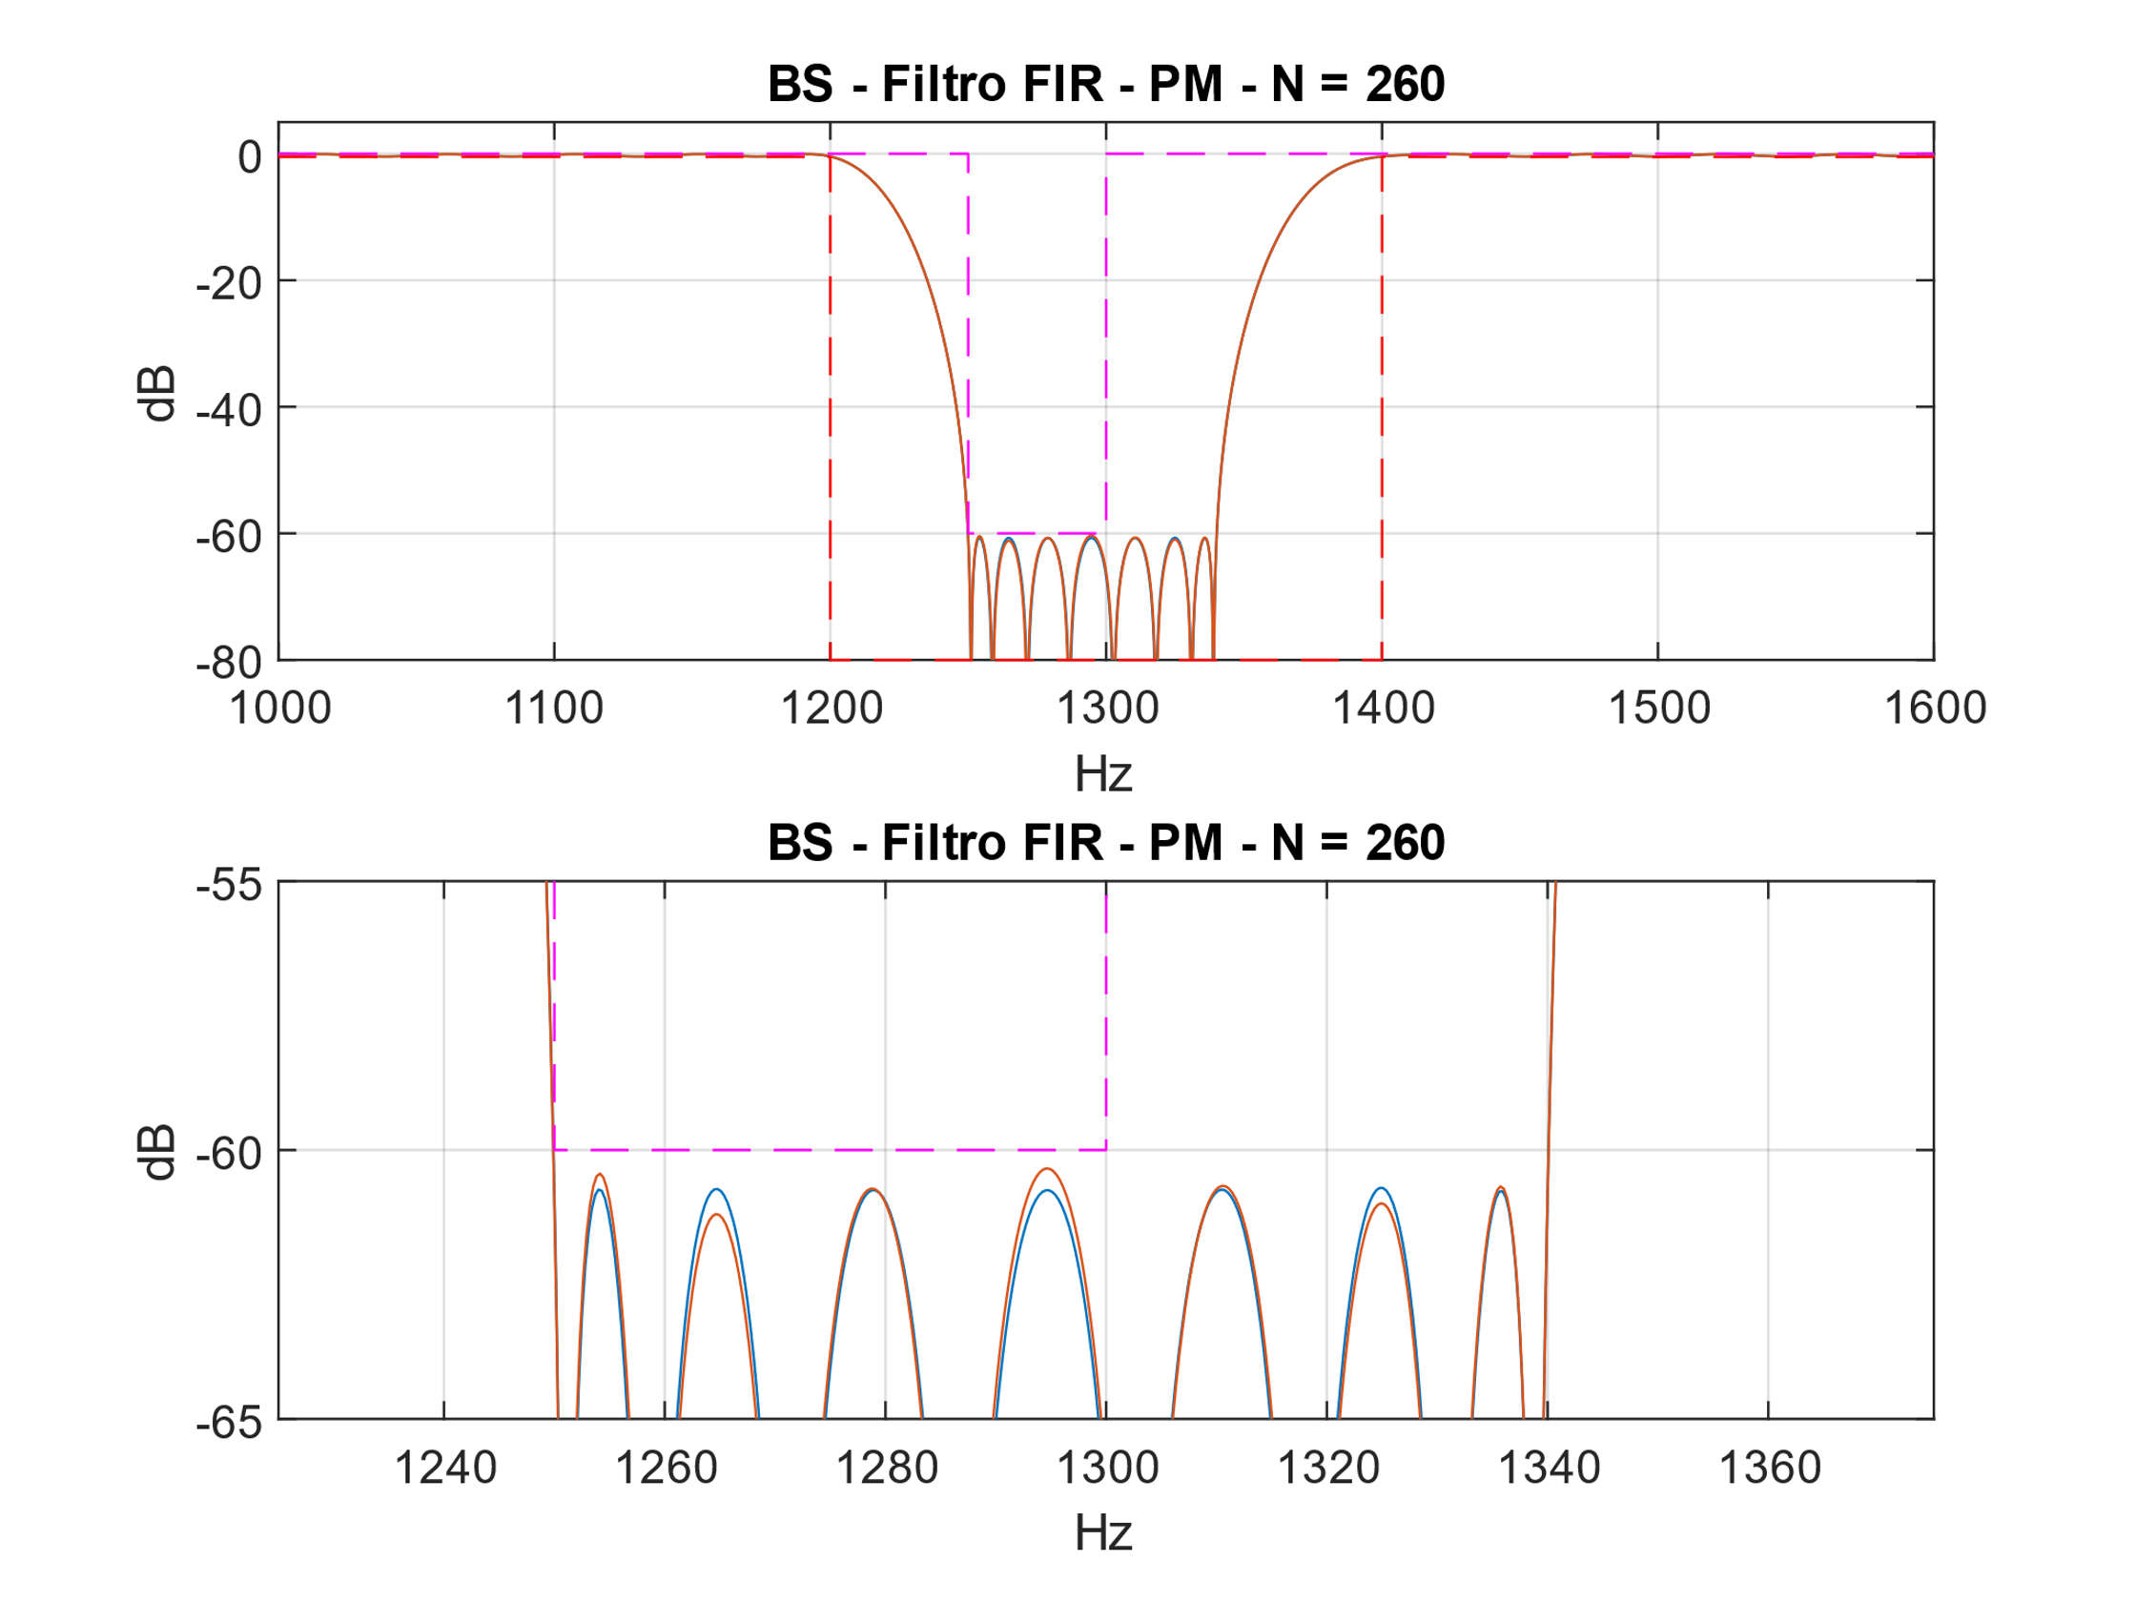

Figura 3 - Filtro DF Symmetric.

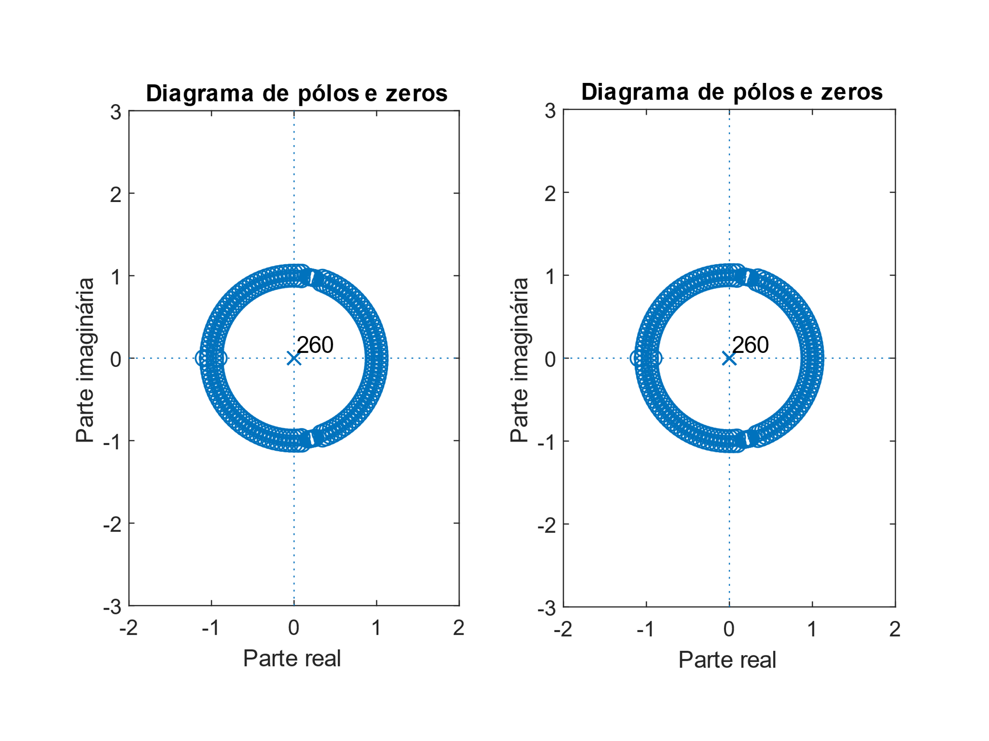

Figura 4 - Filtro DF Symmetric.

ASIC:

(2M + S + D) * nº bits

(2 * 131 + 261 + 260) * 18 = 14094elementos

FPGA:

(2M + S) * nº bits

(2 * 131 + 261) * 18 = 9414 elementos